* **Substitution Ciphers**

**Additive Cipher**

**#encryption and decryption**

text=input("Enter your text:")

s=int(input("Enter your Key:"))

def encrypt(text,s): **#function for Encryption**

result = ""

for i in range(len(text)):

char = text[i]

if (char.isupper()):

result += chr((ord(char) + s-65) % 26 + 65)

else:

result += chr((ord(char) + s-97) % 26 + 97)

return result

def decrypt(text,s): **#function for Decryption**

result = ""

for i in range(len(text)):

char = text[i]

if (char.isupper()):

result += chr((ord(char) - s-65) % 26 + 65)

else:

result += chr((ord(char) - s-97) % 26 + 97)

return result

Etext=encrypt(text,s)

Dtext=decrypt(Etext,s)

print('Encrypted text: ',Etext)

print('Decrypted text: ',Dtext)

**Output**

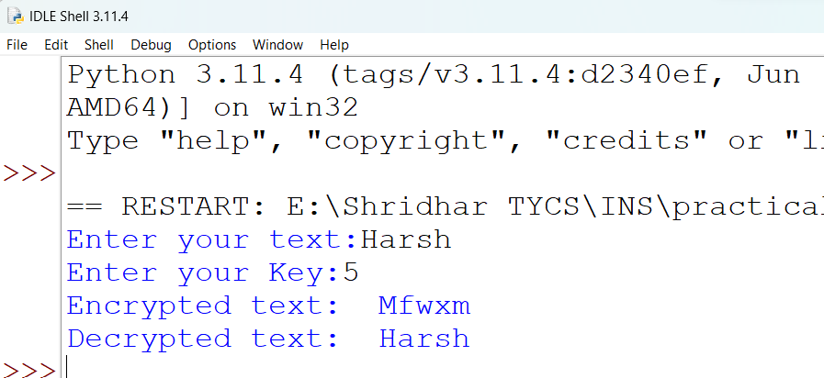

**Multiplicative Cipher**

**Code**

def multiplicative_cipher(text, key):

return "".join(chr((ord(c) - 65) * key % 26 + 65) if c.isalpha() else c for c in text.upper())

def mod_inverse(a, m):

for x in range(1, m):

if (a * x) % m == 1:

return x

return None

def multiplicative_decipher(text, key):

inverse_key = mod_inverse(key, 26)

if inverse_key is None:

return "Error: Invalid key. The modular inverse does not exist."

return "".join(chr((ord(c) - 65) * inverse_key % 26 + 65) if c.isalpha() else c for c in text)

# Example usage

plaintext = input("enter your plain text")

key = int(input("enter your key value "))

encrypted_text = multiplicative_cipher(plaintext, key)

decrypted_text = multiplicative_decipher(encrypted_text, key)

print("Plaintext:", plaintext)

print("Encrypted Text:", encrypted_text)

print("Decrypted Text:", decrypted_text)

**Output**

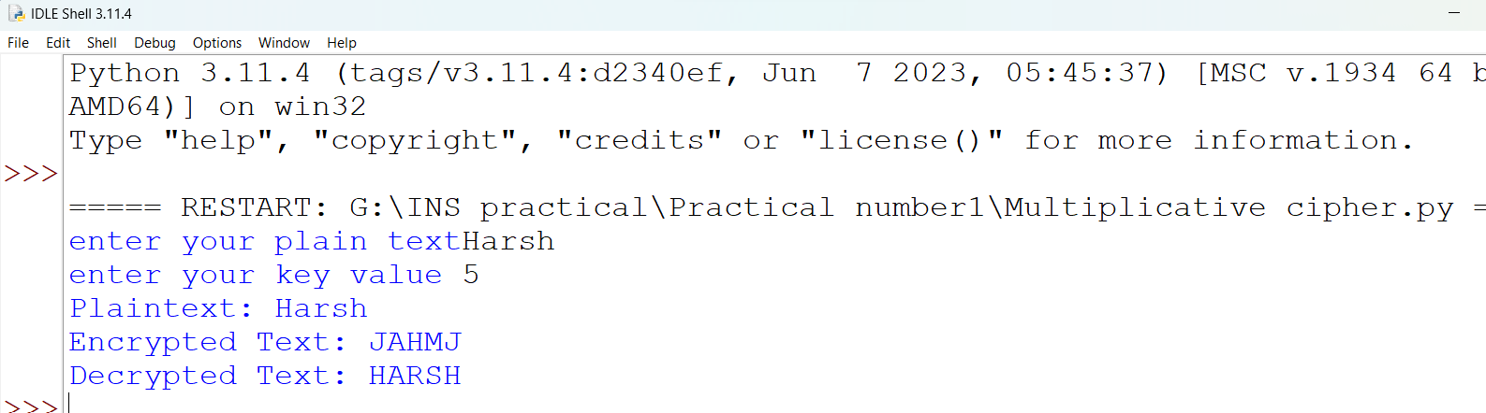

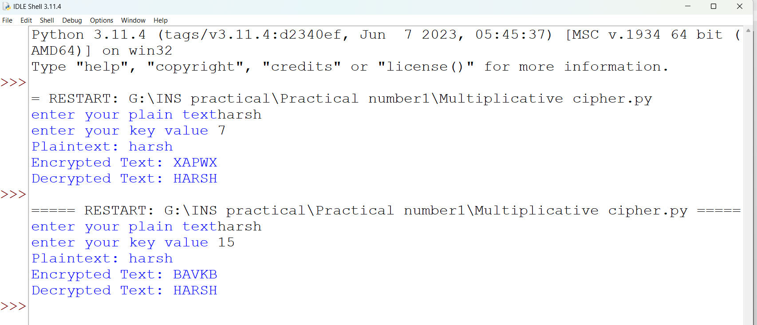

* **Transposition ciphers**

**Rail fence**

print("Rail_fence algorithms:")

string=input("Enter the string:")

t=[]

def encry(string):

tt=len(string)

if (tt%2) == 0:

for i in string:

if (string.index(i)%2) == 0:

t.append(i)

for i in string:

if (string.index(i)%2)!= 0:

t.append(i)

else:

for i in string:

if (string.index(i)%2) == 0:

t.append(i)

for i in string:

if (string.index(i)%2)!= 0:

t.append(i)

encry(string)

print(t)

**Output**

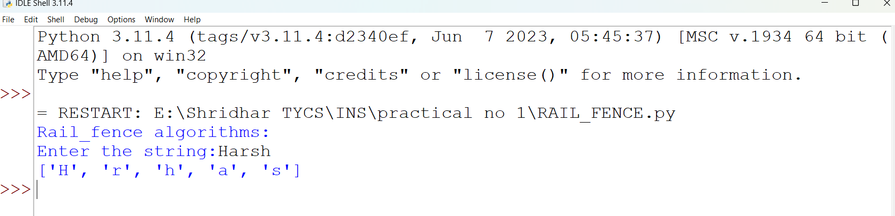

**Columner Cipher**

**Code**

import math

key = "ABC"

**# Encryption**

def encryptMessage(msg):

cipher = ""

k_indx = 0

msg_len = float(len(msg))

msg_lst = list(msg)

key_lst = sorted(list(key))

col = len(key)

row = int(math.ceil(msg_len / col))

fill_null = int((row * col) - msg_len)

msg_lst.extend('_' * fill_null)

matrix = [msg_lst[i: i + col]

for i in range(0, len(msg_lst), col)]

for _ in range(col):

curr_idx = key.index(key_lst[k_indx])

cipher += ''.join([row[curr_idx]

for row in matrix])

k_indx += 1

return cipher

**# Decryption**

def decryptMessage(cipher):

msg = ""

k_indx = 0

msg_indx = 0

msg_len = float(len(cipher))

msg_lst = list(cipher)

col = len(key)

row = int(math.ceil(msg_len / col))

key_lst = sorted(list(key))

dec_cipher = []

for _ in range(row):

dec_cipher += [[None] * col]

for _ in range(col):

curr_idx = key.index(key_lst[k_indx])

for j in range(row):

dec_cipher[j][curr_idx] = msg_lst[msg_indx]

msg_indx += 1

k_indx += 1

try:

msg = ''.join(sum(dec_cipher, []))

except TypeError:

raise TypeError("This program cannot","handle repeating words.")

null_count = msg.count('_')

if null_count > 0:

return msg[: -null_count]

return msg

**# Driver Code**

msg = input("Enter the Message : ")

cipher = encryptMessage(msg)

print("Encrypted Message: {}".

format(cipher))

print("Decryped Message: {}".

format(decryptMessage(cipher)))

